AI Security Tools Using ChatGPT
- Objective
The aim is to make three small security tools using AI prompts and test how correct they are. We will use websites like MX Toolbox (for domain/IP checks)
- Overview
• Checking domain/IP reputation – AI explains if an IP or domain looks suspicious using MX Toolbox results.
• Analysing malware info – AI summarizes malware details using Malware Bazaar data.
• Sorting logs or alerts – AI decides if logs are normal, suspicious, or malicious.
- Step By Step

Tool 1: Phishing Email Detector using Mx tool and AI
For GPT: "Analyze this email and tell if it is phishing."
MX Tool: Open your Mail Inbox and Select a phishing mail from your Spam or Updates
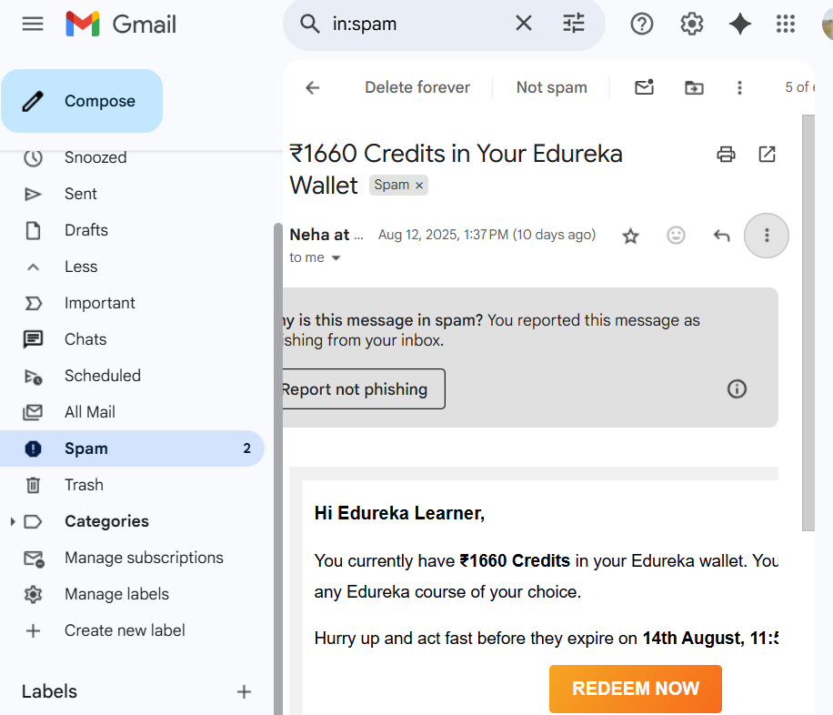
Step 1: Click on Three Dots select show original Click on copy header

Step 2: Open Browser search for the MX Tool Email Header Analyzer Paste the Copied header Analyze the result

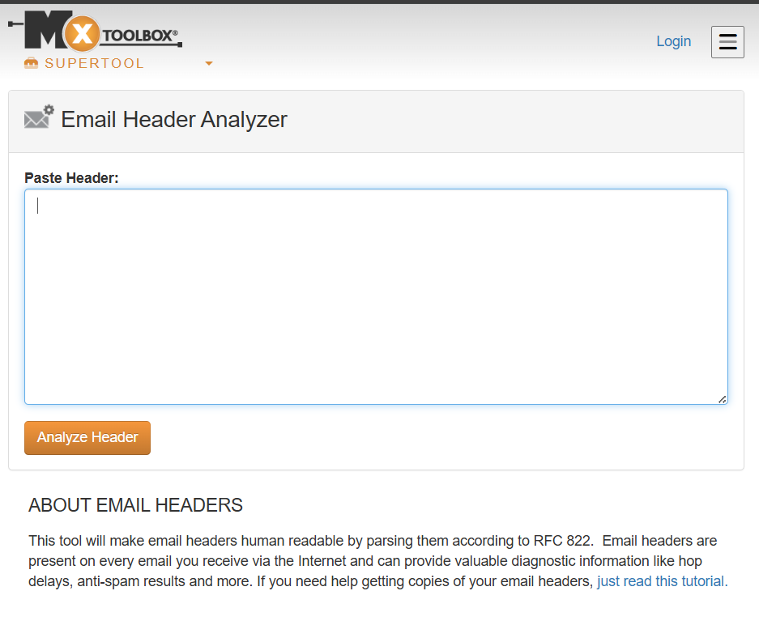
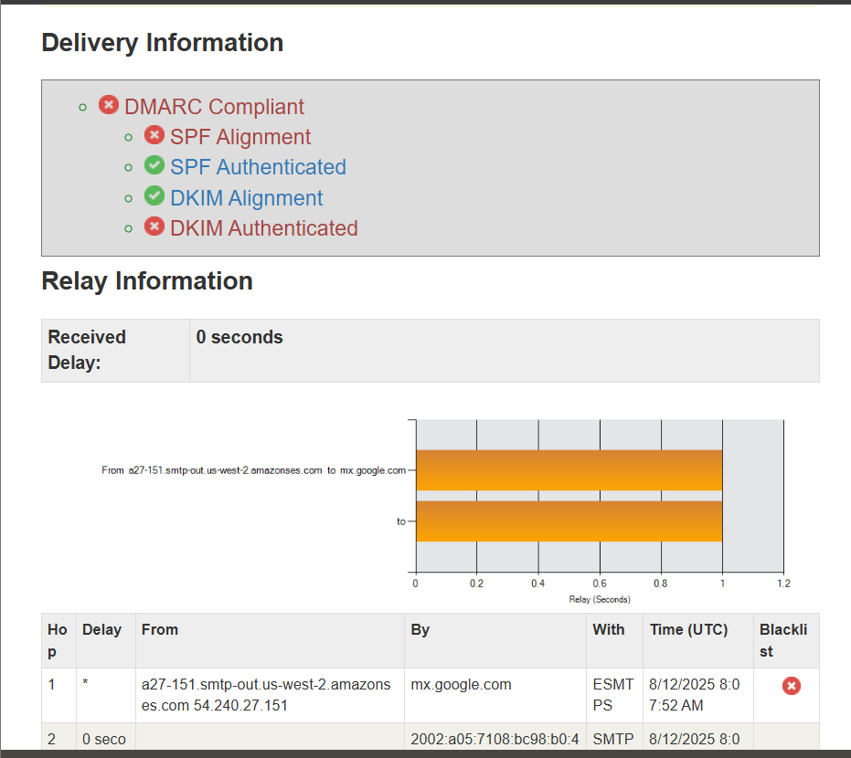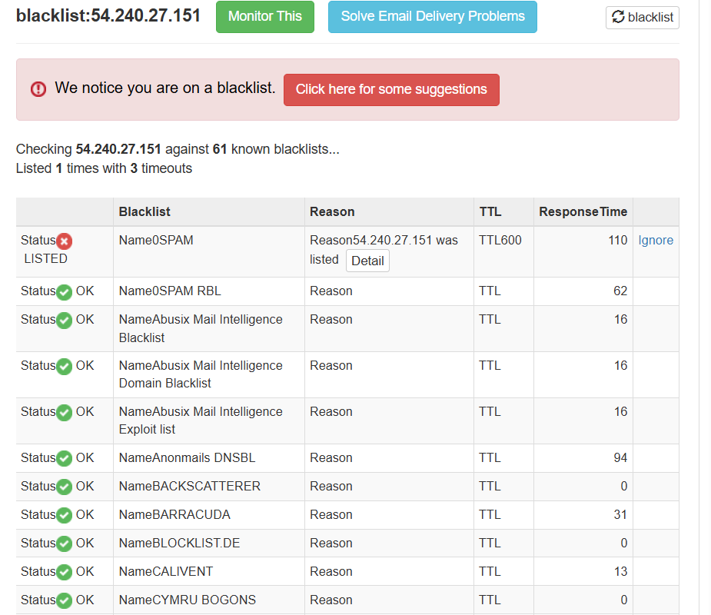

The Tool Says that the IP was in blacklist, now let us see the GPT output

Step 3: Open any GPT And paste the Copied Header / you can attach Downloaded Header and Prompt given above
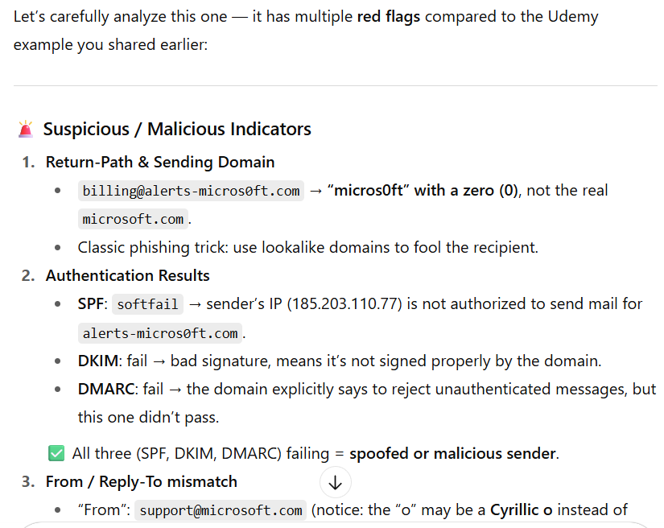

Tool 2: Malware Code Analyzer
- For Analyzing the malware also, we are having different open-source tools which are using ai in the backend. we will the observe the tool output and GPT output
Prompt: "Check this script and explain if it looks like malware."
Step 1: Open Browser Search for VirusShare.com Copy the Hash Value or you can download the file and attach the file to GPT and Run the given prompt
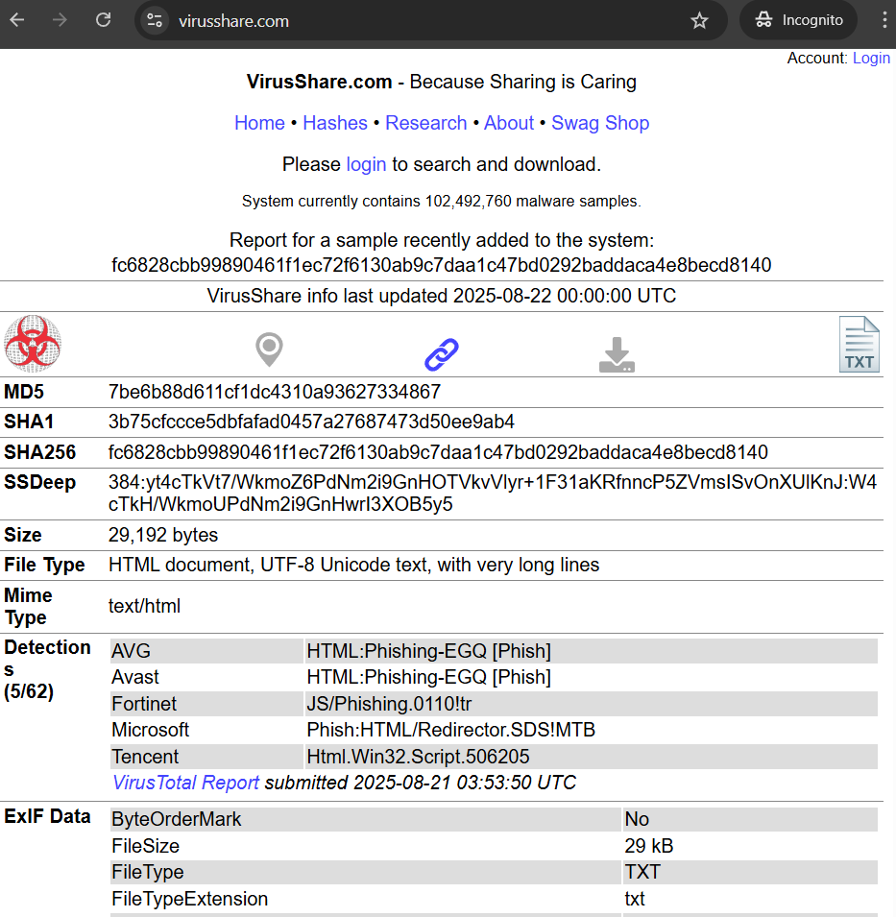
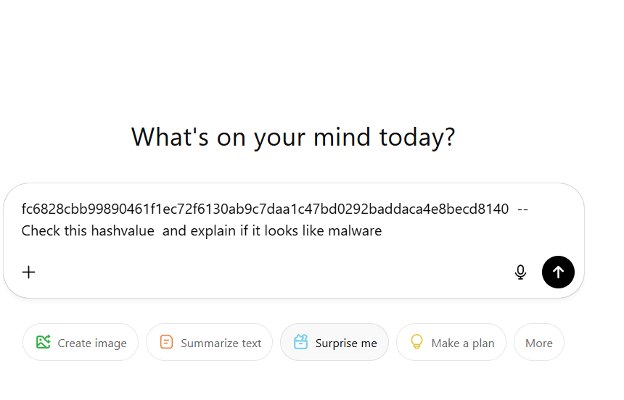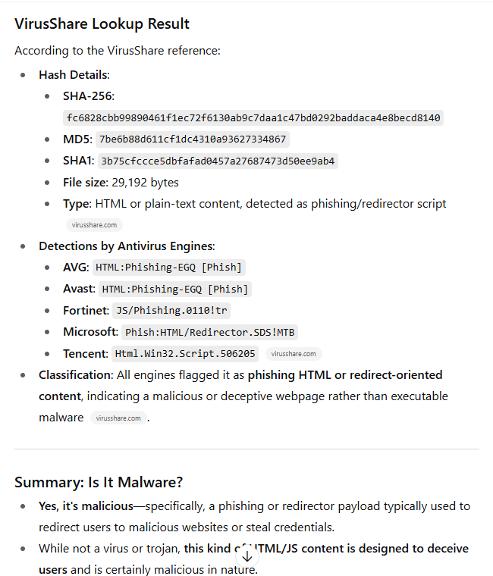
Step 2: Open Browser Search for Virus total paste the hash value in search
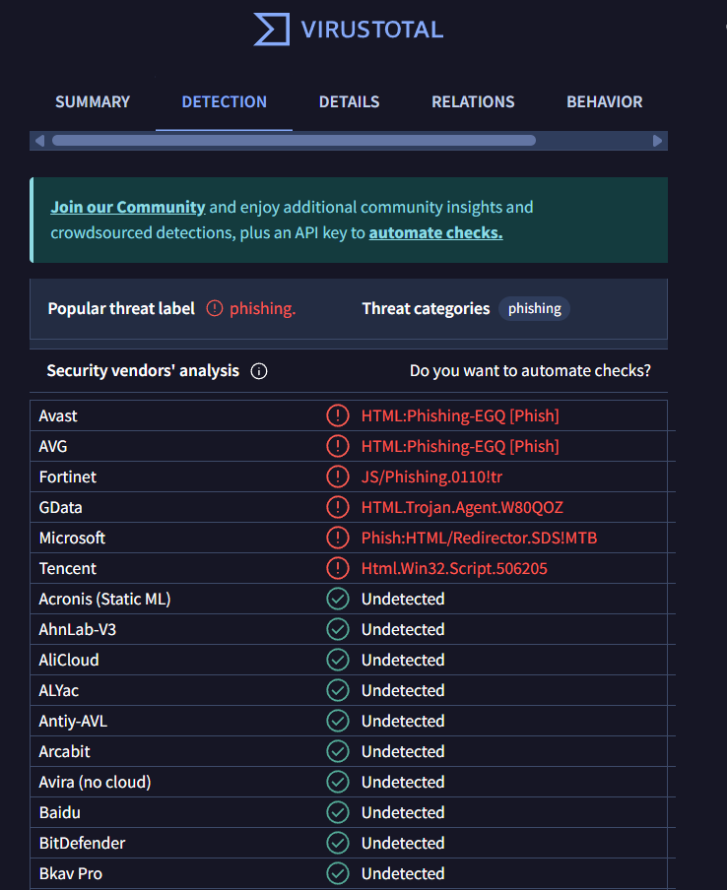

Tool 3: Security Log Analyzer
Prompt: "Analyze this Windows Event Log entry and explain if it is harmful."
Step 1: Search for Event Viewer in your machine select Windows log Select Security Select any event click on Event Properties
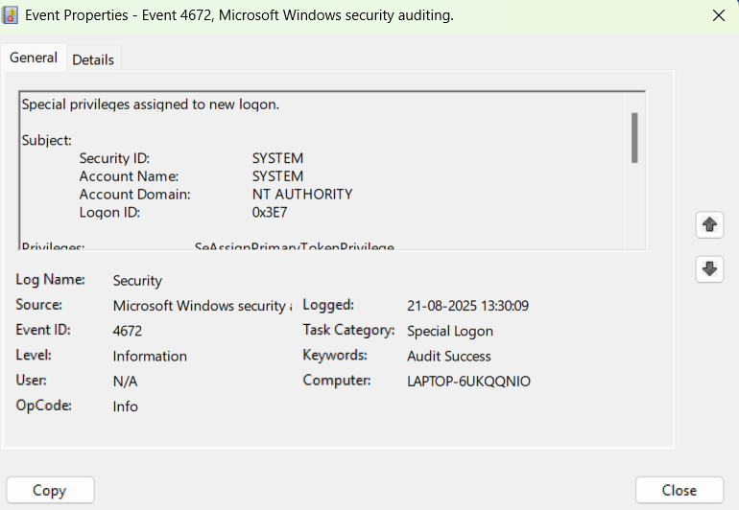
Step 2: Open GPT Attach the Image of the Event Paste the Given Prompt
